Exercise: 24 pts

You are provided with three files:
- db.sql – an SQL script that will create a database to be used.
- Jquery-3.6.3.min.js – the minified JQuery version 3.6.3 library to be used.
- frontEnd.html – an html file that should be used as the starting point for this exercise.
You are NOT allowed to change ANY of these files. Any changes you will make to these files will not be taken into consideration. The final corrections for your files will be made against THESE same provided files.
When you open the provided, frontEnd.html file in a browser, you will see the following result:
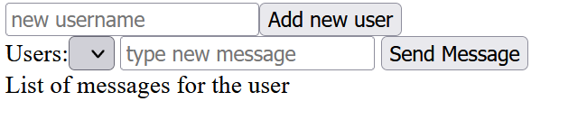
Your goal is to implement a JS file (called frontEnd.js) that will make AJAX requests to a backEnd.php file to do the following:
- Fill in the list of available Users (from the database) in the select list.
6 points

- Allow a website user to Add a new user into the database and refresh the select list of users.
6 points

- Allow the website user to Send messages (insert it into the database) for the selected User.
6 points

- Show a list of messages that the current Selected user has sent instead of the “List of messages for the user” (you should replace that text with the messages written by the selected user).
6 points
Please check the front-class projector for the exact working solution of this exercise.

Zip the two created files (frontEnd.js and backEnd.php) and upload the results as a deliverable to the assignment.
Time allowed: 100 minutes.
Good luck!

